This is the document: <text name="test1"/>
<text name=test2/>
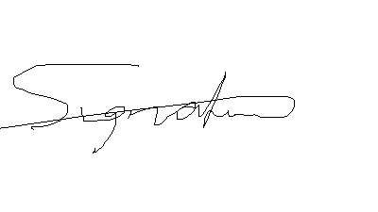
signature

